27.29: a) 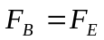 so 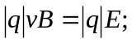 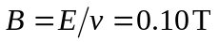
Forces balance for either sign of 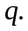
b) 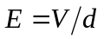 so 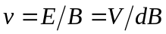
smallest
largest 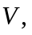smallest 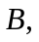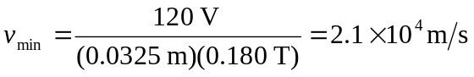
largest
smallest largest 